INSTRUCTIONS FOR PREPARING ICPT 2026 ABSTRACTS

Taesung Kim¹, Jin-Goo Park², and Sangwoo Lim^{3,*}
¹ Sungkyunkwan University, Suwon, 16419, South Korea
² JG Wet Solutions Co., Ltd., Ansan, 15588, South Korea
³ Yonsei University, Seoul, 03722, South Korea

*Corresponding e-mail: swlim@yonsei.ac.kr

Abstracts are limited to one page of text and may include supporting figures. The document must be formatted for A4 paper (21 x 29 cm) with margins of 2.5 cm on the top, 1.5 cm on the bottom, and 2.0 cm on both sides. Submissions must be in PDF (strongly preferred) and Microsoft Word (.docx or doc) format.

The abstract title should be 14-point bold Arial, centered. After a single 14-point blank line, list the authors' names (First Name Last Name) in 12-point Arial, centered. Immediately below the names, provide the author contact information in 10-point Arial, centered, including the organization, city, state (or region), postal code, country, and email address.

Insert a double blank line (10-point) between the contact info and the main text. The body text should be 10-point Arial or Symbol font in a double-column format. Paragraphs must be single-spaced and fully justified, with a blank line between each paragraph. References should be cited in square brackets [1].

After the abstract text, please list the corresponding author’s details (name, phone, email, affiliation, and address). Additionally, indicate your preference for Oral or Poster presentation and specify the Topic Area from the ICPT 2026 website.

Note that all presenters are required to submit an extended abstract by September 5 and the template will be available on July 3, 2026.

Topics
- Advanced Interconnect CMP
- Dielectric & Hard Materials CMP
- CMP Consumables
- CMP Fundamentals
- Post-CMP Cleaning and Defect Engineering
- Metrology & Inspection, Equipment, Process Diagnostics
- AI & ML for CMP, Process Control
- Sustainable CMP and Manufacturing Readiness
- CMP for Advanced Packaging & 3D Integration
- Emerging and Alternative CMP Technologies

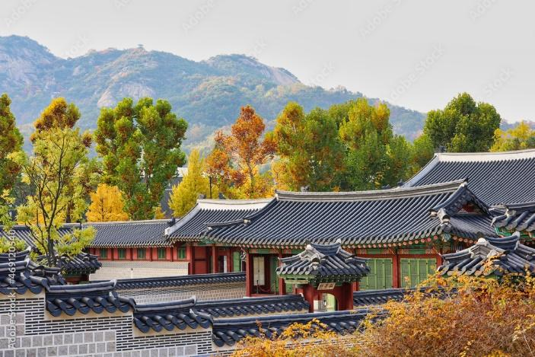

Fig.1 A royal autumn in the heart of Seoul, Gyeongbokgung

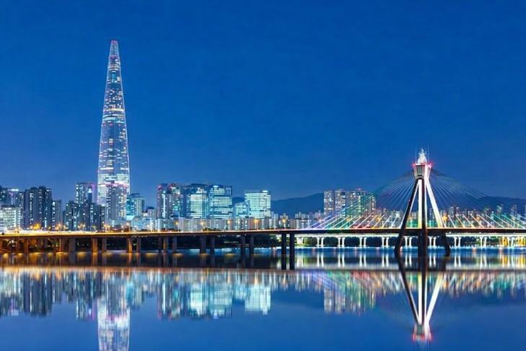

Fig.2 Seoul Night Scene

